

##### JOB DESCRIPTION

##### JOB TITLE: Head of Human Resources – Integrated Urgent Care

**RESPONSIBLE TO: Service Director of Integrated Urgent Care**

**PROFESSIONAL DOTTED LINE: Group Director of HR**

**JOB SUMMARY**

Practice Plus Group is a leading Healthcare organisation with 3 divisions of activity supported by a group of central support colleagues. This role is Head of Human Resources for Integrated Urgent Care and requires the post holder to work collaboratively with the HR leads for the other divisions on a regular basis.

Our mission at Practice Plus Group is **Access to Excellence.**

Our core values are:

* We treat patients and each other as they would like to be treated
* We act with integrity
* We embrace diversity
* We strive to do things better together

The primary focus of this role is to provide both strategic and operational HR leadership for the ‘Integrated Urgent Care (IUC) Service’ which covers NHS111, Clinical Assessment Service (CAS), GP Out of Hours, GP Practices and Urgent Treatment Centres. The Head of HR will ensure the effective coaching and development of Senior and Operational Management Teams in all areas of people management activity, including complex employee relations case work, succession planning, change management and TUPE. Leading a team of HR, Resourcing and internal communications/engagement professionals, the Head of HR will be required to understand the service challenges and objectives in order to deliver commercially focussed HR solutions that support service delivery and improvement. The postholder will be a core member of the Integrated Urgent Care Senior Leadership Team, supporting strategic decision making.

### Principal Duties and Responsibilities

* Through the management and leadership of the IUC HR team, position the role of HR as an integral part of the service;
* Develop effective partnership working, influencing change and challenging approach were necessary;
* Ensure management capabilities within the service meet required standards, lead the analysis of management capability and succession planning, and ensure that any non-compliance is addressed through the correct channels;
* Ensure from an Organisation Development perspective the service line remains a modern and proactive employer, responding to the changing needs of our workforce to support a well recruited clinical team;
* Equip managers with appropriate tools and knowledge to effectively manage their teams; act as the change advocate encouraging buy-in with approaches to increase management capability and utilise services delivered via the HRBP team;
* Lead the development and implementation of a service specific HR Strategy and Plan to tackle turnover, increase engagement and improve management capability;
* Lead the recruitment planning in conjunction with the Regional Directors and other key stakeholders.
* Support any necessary research, design and the subsequent implementation of HR initiatives in support of the IUC HR Plan and wider HR priorities;
* Lead the internal communications and engagement initiatives across IUC, supporting team members with events, activities and plans.
* Introduce and embed a metrics driven approach to people management and ensure pro-active interventions to reduce missing capacity including absence and turnover;
* Provide expert advice and guidance in support of transformational change, restructures, TUPE and redundancy; ensure commercially focussed approach to improve cost and efficiency;
* Lead on the workforce section of all IUC bidding processes, as the SME offer compelling workforce solutions and narrative in support of new business development opportunities;
* Where requested provide updates to commissioners on all people related activities either in person or via reporting;
* Lead HR activity, acting as the subject matter expert in relation to the application and implementation of TUPE and associated mobilisation initiatives;
* Undertake project work where appropriate and as requested by the IUC Director;
* To lead the Resourcing Team , ensuring all vacancies within IUC are filled cost effectively and with minimal time to hire periods;
* To work closely with The Resourcing Operations Manager to ensure post recruitment administration, and starters’ documentation is completed in a timely and efficient manner in accordance with our regulatory framework with positive candidate experience being a key focus;
* Maintain positive control of the HR budget, engaging with colleagues as appropriate to ensure anomalies are addressed and budget control is maintained;
* To work with HRIS team ensuring the I-Trent HR information system is providing meaningful Management Information, for example, relating to staff turnover, sickness absence costs, temporary workforce spend, that is timely and accurate for the relevant services;
* To provide expert advice to support the tax compliance activity within IUC for those workers engaging on a self-employed or Limited Company basis;
* To provide expert support to service management teams to meet all regulatory requirements relating to statutory bodies such as the Care Quality Commission (CQC) etc.

**Resourcing**

Ensure that resourcing remains a key focus area and the high volume, fast paced activity remains as such. Ensure resourcing team members deliver bespoke recruitment solutions as required and undertake a high level of stakeholder engagement through resourcing processes. Working collaboratively with Regional Directors on resourcing requirements both imminently and in preparation for the future.

To be the authorising officer for IUC visas and immigration.

**Learning & Development**

You will lead the Learning & Development work by creating effective strategies which focus on people development across the service. Planning and introducing new opportunities for employees in support of overall organisational development and growth. Using all opportunities to create and promote synergies which work in the best interests of the service.

Provide organisational development support for the Senior Leadership Team through succession planning and talent mapping as well as ensuring appropriate development opportunities exist for the growth and sustainability of the IUC workforce.

**HR Business Partnering**

To lead a team of HR professionals whose purpose is to effectively manage all employee relations matters, improve manager capability, contribute to the IUC HR Strategy through proactive work which builds and shapes our culture, workforce practices and supports employee wellbeing. To lead on complex casework, offering expert advice and pragmatic commercially focussed business solutions. You will be a critical friend to SLT members on all people related matters and be the voice of our people in wider business-related discussions.

**Communication and Engagement**

Responsible for defining and delivering the overall internal IUC communications and engagement strategy for our workforce, which connects to, and enhances, our IUC strategic intentions.

Ensuring all activity contributes to a culture where feedback is encouraged, supported and where staff feel work environments are happy, fun places to be whilst delivering their core objectives.

**Key stakeholders:**

IUC Senior Leadership Team

Group Head of Tax

Head of HR – Health in Justice

Group HR Director

Primary Care Medical Director

Executive Director of Nursing & Safeguarding

HRIS Manager

Head of HR Operations

This job description is intended as a basic guide to the scope and responsibilities of the post and is not exhaustive. It will be subject to regular review and amendment as necessary in consultation with the post holder.

**Team Structure**

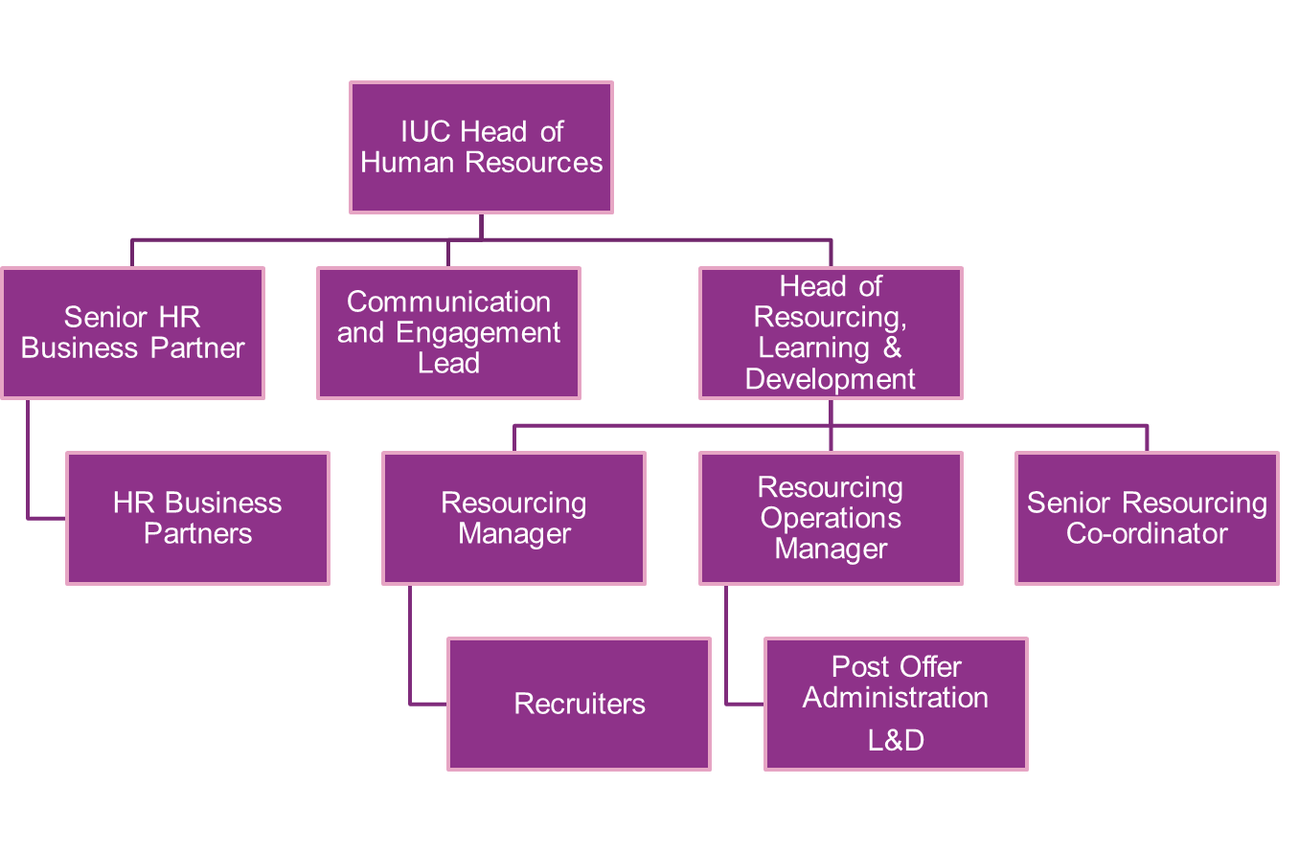

|  |
| --- |
| **Person Specification – Head of HR - IUC** |

|  |  |
| --- | --- |
| **CRITERIA** | **ESSENTIAL** |
| Qualifications | Chartered Member of the CIPD or equivalent experience |
| Experience | Considerable relevant experience in a fast paced, large and complex environment, delivering commercially focussed HR solutions  NHS, clinical or public sector experience  Experience of working in a commissioned contracting organisation.  Leadership experience of a range or HR professionals in a complex organisation. |
| **Skills and Knowledge** | Good knowledge of employment law and TUPE as well as bidding and pensions issues relating to public sector outsourcing.  Knowledge of tax compliance for contractors would be advantageous.  Experience in leading innovative and effective recruitment solutions  Ability to influence and shape senior management opinion.  The ability to prioritise a demanding workload effectively in order to meet deadlines whilst maintaining attention to detail.  Ability to convey advice clearly and concisely with conviction and in a persuasive manner when in a difficult and challenging environment.  Excellent interpersonal skills and able to work and organise quickly, accurately, and productively.  High standard of verbal and written communication skills.  Able to simultaneously and successfully manage different projects. |
| Other Factors | Mobile and able to undertake national travel as necessary  Ability to attend regular quarterly IUC conferences over 3 days and 2 nights. |

**Additional Information:**

**Conflict of Interests**

You may not without the consent of Practice Plus Group engage in any outside employment and in accordance with our Conflict-of-Interest Policy you must declare to your manager all private interests, which could potentially result in personal gain as a consequence of your employment position with us. Interests that might appear to be in conflict should also be declared.

**Confidentiality**

The post holder is required not to disclose such information, particularly that relating to patients and staff.  All employees are subject to the Data Protection Act 1998 and must not only maintain strict confidentiality in respect of patient and staff records, but the accuracy and integrity of the information contained within.  The post holder must not at any time use personal data held by Practice Plus Group for any unauthorised purpose or disclosure such as data to a third party.  You must not make any disclosure to any unauthorised person or use any confidential information relating to the business affairs of Practice Plus Group, unless expressly authorised to do so by Practice Plus Group.  Further guidance on confidentiality is contained within our Information Security Management System (ISMS).

**Data Protection**

The post holder must at all times respect the confidentiality of information in line with the requirements of the Data Protection Act and the company’s ISO27001 accreditation.  This includes, if required to do so, obtain, process and/or use information held on a computer in a fair and lawful way, to hold data only for the specified registered purposes and to use or disclose data only to authorized persons or organizations as instructed.

**Education and Training**

Personal continuing professional development is encouraged and an annual appraisal system is in place to discuss CPD and ongoing objectives.

**Equity, Diversity, and Inclusion**

The post holder is required at all times to carry out responsibilities with due regard to our Equity, Diversity, and Inclusion Policy framework and the relevant statutory provisions.

**Health and Safety**

As an employee of Practice Plus Group, the post holder has a duty under the Health and Safety at Work Act 1974, to:-

* Take reasonable care of the health and safety of themselves and all other persons who may be affected by their acts or omissions at work.
* Co-operate with their employer to ensure compliance with Health and Safety legislation and our Health and Safety policies and procedures, not intentionally or recklessly interfere with, or misuse, anything provided in the interests of health, safety, or welfare, in pursuance of any of the relevant statutory provisions.

**Risk Management**

All members of staff have a responsibility to report all clinical and non-clinical accidents or incidents promptly and when requested to, co-operate with any investigation undertaken.

This list of duties and responsibilities is by not exhaustive and the post holder may be required to undertake other relevant and appropriate duties as reasonably required.