Post Title | Group Chief Pharmacist
Organisation | Practice Plus Group Hospitals
Contract Type | 2 year Fixed Term 37.5hrs per week
Salary | Up to £110k DoE (benefits: PMI, car allowance)
Reports To | Group Clinical Director of Strategy and Transformation
Accountable To | Group Chief Medical Officer (dotted line)
Location | National (remote with regular travel across PPG hospitals and head office is)

Background and Context
Practice Plus Group (PPG) is one of the UK's leading independent healthcare providers, delivering NHS and private healthcare through a national network of hospitals, treatment centres, and community health services. PPG is committed to making healthcare accessible, delivering consistently high clinical standards and outstanding patient experience.
Following the promotion of the current incumbent, this post has been created on a fixed-term basis for two years to provide senior pharmacy leadership during a pivotal period of organisational transformation. The Group Chief Pharmacist will sit at the heart of PPG's strategic agenda, driving the transformation of pharmacy services across the Group and enabling the expansion of clinical specialties including medical specialties, specialist medicine, and oncology.
This is an unambiguously strategic, system-level role. The post holder will not only lead the operational and clinical standards of pharmacy across all PPG hospital sites but will fundamentally reshape the way in which pharmacy services are conceived, structured and delivered - re-establishing pharmacy as a clinical and commercial cornerstone of the Group's growth ambitions.

Organisational Structure and Reporting Lines
The Group Chief Pharmacist reports directly to the Group Clinical Director of Strategy and Transformation, who has a dual reporting line to the Group Chief Medical Officer and the Group Chief Operating Officer. The post holder also holds dotted-line professional accountability to the Group Chief Medical Officer.
The post holder will directly manage the Group Associate Chief Pharmacist and provide leadership to Pharmacy Leads across PPG’s network of sites. Alongside the Group Chief Nurse and Deputy Director of Infection Prevention and Control, the Group Chief Pharmacist is a key member of the senior corporate governance team, providing assurance to the Board on the safety and quality of care provision.
The Group Chief Pharmacist will chair and co-chair key governance committees and lead the Pharmacy Senior Leadership Group nationally.
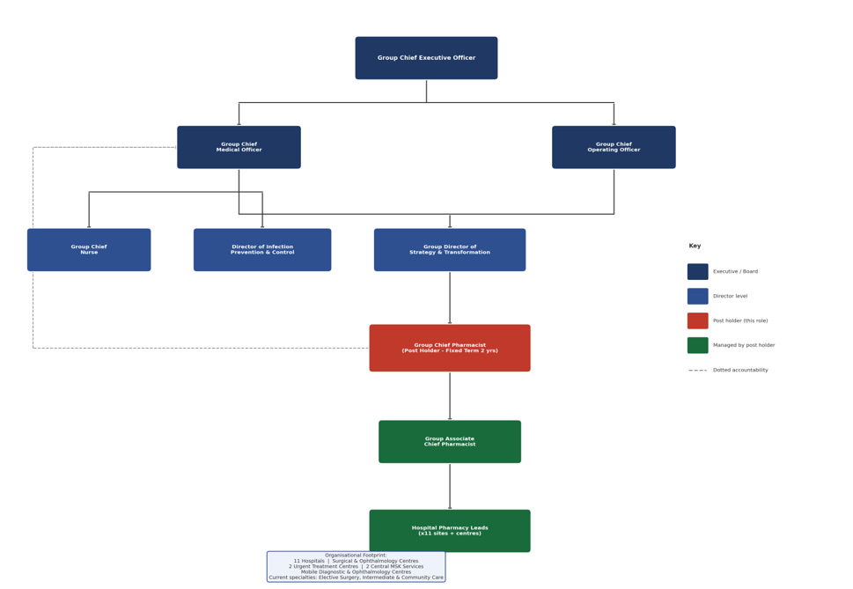

Organisational Footprint
Practice Plus Group operates one of the largest independent sector healthcare networks in the UK. The Group Chief Pharmacist will hold strategic pharmacy leadership responsibility across the full breadth of this footprint, which currently comprises:
- 10 hospitals/surgical centres providing elective (inpatient and day-case care) and diagnostic services
- 1 ophthalmology centre delivering high-volume ophthalmology services.
- 2 Urgent Treatment Centres (UTCs) providing community-facing urgent care
- 2 MSK (Musculoskeletal) services delivering community and specialist MSK pathways
- Mobile diagnostic units and ophthalmology centres providing community-based diagnostic and outpatient services
The current clinical portfolio is centred on elective surgery, diagnostics and intermediate care. The organisation is now entering a significant phase of specialty expansion - encompassing medical specialties, specialist medicine, and oncology - which will fundamentally alter the complexity and profile of the pharmacy service required across the Group.

Job Summary
Reporting to the Group Director of Strategy and Transformation and professionally accountable to the Group Chief Medical Officer, the Group Chief Pharmacist will provide inspirational, system-wide clinical and professional leadership for all pharmacy services across Practice Plus Group Hospitals.
The post holder will take executive responsibility for the development and delivery of the Group's Pharmacy Transformation Programme, ensuring pharmacy services are positioned to support significant specialty expansion - including the establishment of medical specialties, specialist medicine, genomics, and oncology pathways - while re-establishing the model of pharmacy service delivery to meet the needs of a growing, increasingly complex healthcare organisation.
The Group Chief Pharmacist will hold the statutory responsibilities of Chief Pharmacist across PPG Hospitals, in line with all relevant statutory regulations, hospital pharmacy standards, and GPhC standards for Chief Pharmacists.
The post holder will provide visible, authoritative professional leadership to all pharmacists, pharmacy technicians, trainees and pharmacy support staff nationally.

Key Working Relationships
The post holder will be expected to establish and maintain productive relationships with:
- Group Clinical Director of Strategy and Transformation (line manager)
- Group Chief Medical Officer (professional accountability)
- Group Chief Nurse and Deputy Director of Infection Prevention (members of Central Governance Team)
- Associate Chief Pharmacist and Pharmacy Leads (reportees)
- Hospital Medical Directors and Clinical Directors
- National and site-level Senior Leadership Teams
- PPG Transformation and Innovation Programme teams
- Clinical Specialty Leads
- Operational, clinical, and specialist teams across all PPG sites
- Corporate functions: Finance, Procurement, HR, IT, Estates, Commercial
- NHS England, NHS Regional Pharmacy Deans, GPhC, CQC, and other regulatory bodies
- Integrated Care Systems and NHS commissioners
- Academic and training partners, including Higher Education Institutions, neighbouring NHS trusts and community pharmacies
- Patients, service users, and their families

Key Responsibilities

1. Strategic and Transformational Leadership
- Lead the development and delivery of a compelling, forward-looking national pharmacy strategy for PPG, aligned to the Group's Organisational Transformation Plan and growth ambitions.
- Act as the senior executive accountable for the PPG Pharmacy Transformation Programme, redefining the operating model for pharmacy service delivery across all hospital sites.
- Drive the strategic integration of pharmacy services into newly established and expanding clinical specialties - ensuring pharmacy is an active partner in clinical pathway design from inception.
- Contribute to the Group's corporate strategy as a member of the senior clinical leadership community, providing pharmacy and medicines optimisation expertise at board and executive level.
- Champion innovation in clinical practice, including the digitisation of clinical and pharmacy processes, the sustainable and ethical use of AI and automation, and the adoption of emerging therapeutics.
- Represent PPG in national and regional pharmacy forums, ICS structures, and professional networks, raising the profile of PPG as a leading employer and innovator in independent health sector.
- Work in close partnership with the Group Director of Strategy and Transformation to embed pharmacy as a strategic enabler of organisational growth and service diversification.

2. Pharmacy Service Redesign and Transformation
- Lead a comprehensive review and redesign of pharmacy service delivery models across PPG Hospitals, establishing contemporary, evidence-based operating frameworks appropriate for a growing multi-site independent provider.
- Mainatin clear, national standards for clinical pharmacy practice, medicines management, and pharmacy operations, with robust assurance and benchmarking mechanisms.
- Maintain PPG tiered pharmacy service model that supports both established surgical pathways and the new specialist and complex medicine portfolios being introduced through specialty expansion.
- Lead the design of pharmacy structures, workforce models, and clinical governance frameworks to support PPG growth strategy.
- Champion advanced and specialist pharmacy roles - including Advanced Clinical Pharmacist, and Pharmacist Consultant posts - as part of a strategic workforce development agenda.
- Lead the implementation and optimisation of electronic prescribing and medicines administration (EPMA) systems and digital pharmacy platforms across the Group.

3. Clinical and Professional Leadership
- Fulfil the statutory responsibilities of Chief Pharmacist across PPG Hospitals, including Controlled Drug Accountable Officer responsibilities.
- Provide visible, authoritative professional leadership to all pharmacy staff nationally, acting as Head of Profession and setting standards of clinical excellence, safety, and accountability.
- Ensure the highest standards of medicines safety, clinical governance, and regulatory compliance are maintained across all sites and in line with GPhC, CQC, MHRA, and NHS standards.
- Develop and maintain robust frameworks for medicines optimisation, formulary management, antimicrobial stewardship, and medicines safety across the Group.
- Provide expert clinical pharmacy input to the development of PPG's specialist medicine, genomics, and oncology programmes, including medicines pathway design, pharmacovigilance, and high-cost medicines governance.
- Lead on the medicines aspects of clinical governance, risk management, patient safety, and quality improvement across the organisation.
- Serve as professional lead and point of escalation for complex medicines-related clinical queries from across the Group.

4. Service Development and Specialty Expansion
- Act as the senior pharmacy lead for PPG's expanding specialty portfolio, providing strategic pharmacy input to business cases, service design, and implementation for medical specialties, specialist medicine, genomics, and oncology.
- Develop pharmacy service proposals and business cases to support specialty growth, including costing models, workforce requirements, and commercial frameworks.
- Build strategic partnerships with pharmaceutical industry, NHS trusts, academic centres, and genomics networks to position PPG as a credible partner in specialist and precision medicine.
- Ensure that formulary development, medicines access, and medicines commissioning arrangements are fit for purpose to support expanded pathways.

5. Governance, Committees, and Quality Assurance
- Serve as a member of the PPG Senior Central Governance Team, contributing to organisational governance, quality oversight, and strategic risk management at the highest level.
- Chair the Group Drugs and Therapeutics Committee (DTC), providing expert medicines leadership and ensuring robust formulary, prescribing, and medicines governance across all PPG sites.
- Chair the Group Medical Gas Committee, holding accountability for the safe management, procurement, and governance of medical gases across the PPG estate.
- Co-chair additional Group-level governance committees as required, providing senior clinical and professional pharmacy leadership to governance structures aligned to CQC and NHS standards.
- Lead and chair the Pharmacy Senior Leadership Group, bringing together pharmacy leaders from across PPG sites to drive shared standards, best practice, and national pharmacy strategy implementation.
- Participate in site assurance visits across PPG hospitals and centres, providing clinical expertise and scrutiny to support regulatory compliance, CQC readiness, and service quality.
- Attend and contribute to the monthly Group Quality Business Review, reporting on pharmacy performance, medicines safety, and transformation progress against agreed KPIs and improvement plans.
- Monitor pharmacy performance metrics and medicines safety parameters on a regular basis, identifying trends, escalating risks, and driving continuous improvement.
- Submit annual pharmacy reports to the PPG Board and relevant governance committees, providing assurance on pharmacy standards, statutory compliance, and strategic progress.
- Prepare and submit exceptional reports as required - in response to serious incidents, emerging risks, regulatory alerts, or significant operational issues - providing timely and authoritative advice to the executive team and Board.
- Ensure PPG's pharmacy services are fully compliant with all relevant legislation, professional standards, and regulatory requirements.
- Establish and maintain a national pharmacy governance framework, including audit, clinical effectiveness, risk management, and medicines safety reporting.
- Ensure that systems are in place across all PPG sites for the safe and secure handling, storage, and supply of medicines, including controlled drugs, high-risk medicines, and investigational medicinal products.

6. Workforce, Education, and Development
- Lead national pharmacy workforce planning, including strategic recruitment, retention, succession planning, and development of a high-performing pharmacy workforce.
- Develop and oversee the national pharmacy education and training strategy, ensuring PPG is an employer of choice and a leading site for pharmacy undergraduate, post-graduate, and specialist training.
- Support the Associate Chief Pharmacist overseeing pharmacist and pharmacy technician foundation training programmes.
- Collaborate with NHS England (or equivalent), universities, and royal colleges to develop specialist and advanced pharmacy training pathways aligned to PPG's specialty expansion.
- Foster a culture of continuous professional development, lifelong learning, and clinical excellence across pharmacy teams nationally.

7. Financial and Commercial Leadership
- Hold accountability for the pharmacy budget nationally, including medicines expenditure, operational pharmacy budgets, and cost improvement planning.
- Lead medicines cost optimisation programmes in partnership with Finance and Commercial teams, including procurement, formulary management, and high-cost medicines review.
- Develop commercially robust business cases to support specialty pharmacy investment, new service development, and technology adoption.
- Contribute to PPG's commercial strategy through the development of pharmacy-adjacent revenue opportunities, including clinical trial activity, specialist pharmacy services, and partnership models.

General Responsibilities
This job description is not exhaustive and the post holder may be required to undertake other duties commensurate with the grade as the needs of the organisation evolve. The post holder will be expected to:
- Maintain statutory and mandatory training in line with PPG requirements.
- Adhere to PPG's values, policies, and standards of conduct at all times.
- Act in accordance with GPhC standards of conduct, ethics, and performance.
- Maintain registration with the General Pharmaceutical Council throughout the appointment.
- Comply with PPG's information governance, data protection, and confidentiality policies.
- Promote equality, diversity, and inclusion in all aspects of the role.

PERSON SPECIFICATION
Criterion | E | D | Evidence
Education and Professional Qualifications
Master of Pharmacy (MPharm) degree or equivalent registerable qualification | E |  | Application
Current registration with the General Pharmaceutical Council (GPhC) | E |  | Application
Formal leadership or management qualification (e.g. MBA, NHS Leadership Academy programme) | E |  | Application
Fellowship of the Royal College of Pharmacy or equivalent professional distinction |  | D | Application
Experience
Substantial experience as Deputy Chief Pharmacist, or equivalent senior pharmacy leadership level in a multi-site organisation | E |  | Application / Interview
Demonstrable track record of leading large-scale pharmacy transformation programmes | E |  | Application / Interview
Experience of chairing or co-chairing governance committees | E |  | Application / Interview
Experience as Controlled Drug Accountable Officer or equivalent regulatory role | E |  | Application / Interview
Proven experience of strategic workforce planning and development of pharmacy teams at scale | E |  | Application / Interview
Experience working within or alongside independent sector, NHS foundation trust, or national provider organisations | E |  | Application / Interview
Experience of system regulation e.g. CQC inspection processes or equivalent | E |  | Application / Interview
Experience of presenting to Board, executive, or equivalent governance structures | E |  | Application / Interview
Experience of genomics, pharmacogenomics, or precision medicine pharmacy service development |  | D | Application / Interview
Experience of SACT pharmacy services and associated governance |  | D | Application / Interview
Knowledge and Skills
Comprehensive knowledge of current medicine legislation, GPhC standards, and regulatory frameworks (MHRA, CQC, NHS England) | E |  | Application / Interview
Demonstrable knowledge of the UK health economy, policy environment, NHS commissiong and the respective roles of the public sector and independent healthcare organisations within the wider healthcare landscape. | E |  | Application / Interview
In-depth understanding of medicines optimisation, formulary management, and medicines safety governance | E |  | Application / Interview
Strong knowledge of specialty and complex medicines, including high-cost medicines, biologic therapies, and oncology therapeutics | E |  | Application / Interview
Knowledge of EPMA systems and digital pharmacy transformation programmes | E |  | Application / Interview
Sound financial acumen including budget management, medicines cost optimisation, and commercial business case development | E |  | Application / Interview
Ability to design, monitor, and report on pharmacy performance metrics and medicines safety parameters | E |  | Application / Interview
Knowledge of education and training frameworks for pharmacy professionals, including pre-registration and post-graduate programmes | E |  | Application / Interview
Leadership and Personal Qualities
Inspirational and credible senior leader with the ability to set strategic direction and influence at executive level | E |  | Application / Interview
Proven ability to lead, motivate, and develop high-performing clinical and operational teams across geographically dispersed organisations | E |  | Application / Interview
Excellent communication and interpersonal skills, with ability to convey highly complex clinical, financial, and strategic information clearly and persuasively to a wide range of audiences — including lay, clinical, and Board-level — both verbally and in writing | E |  | Application / Interview
Skilled negotiator and influencer, with a demonstrable ability to bring diverse stakeholder groups to consensus, facilitate resolution of complex or contested agendas, and secure organisational commitment | E |  | Application / Interview
Resilient, adaptable, and able to operate effectively in a fast-paced, transformational environment | E |  | Application / Interview
Demonstrable commitment to patient safety, clinical excellence, and quality improvement | E |  | Application / Interview
High levels of professional integrity, sound judgement, and ethical practice | E |  | Application / Interview
Inclusive and values-driven leader, committed to equality, diversity, and belonging | E |  | Application / Interview
Willingness and ability to travel nationally across PPG hospital sites as required | E |  | Application / Interview
Ability to manage ambiguity and competing priorities, delivering sustained outcomes under pressure | E |  | Application / Interview
Track record of building productive cross-professional relationships and working collaboratively within multidisciplinary teams | E |  | Application / Interview

**Practice Plus Group is an equal opportunities employer and is committed to creating an inclusive environment for all employees. We welcome applications from all backgrounds and communities.

